**Umbrella Species Guideline**

# USp GENERAL INFORMATION

|  |  |
| --- | --- |
| **Scientific name**: | *Panthera onca* (Linnaeus,1758) |
| **Popular name in Brazil:** | Onça-pintada, Jaguaretê |
| **Name in English:** | Jaguar |
| **Conservation Status**: | Near threatened (NT - IUCN) and Vulnerable (VU - MMA, nº444/2014 - Brazil). |
| **Distribution:** | The original distribution of this animal spanned from Southwest United States to Northern Argentina. Currently The jaguar is officially extinct in the United States, exceedingly rare in Mexico, yet can still be found in Central and South America, notably in Brazil, which boasts the world's largest population of jaguars. Reintroduction efforts for the jaguar are underway in the United States. See figure 1. |
| **Territorial Area:** | The methodology assumes that one Jaguar has a territorial range of 100km² (10,000 hectares) for purposes of calculations of credit. However territorial areas may range from 30 km², in the Pantanal, to 1,300 km², in the Cerrado[1]. |
| **Diet**: | Medium-sized and small mammals (such as peccaries, capybara, deer, and armadillos). |
| **Reproduction:** | Males and females interact for a few days and copulate during this period. After fertilization, gestation begins, which can last between 90 and 110 days. Usually, a jaguar gives birth to one or two cubs, and up to four may be born. The cubs stay with the mother until they are about two years old. |
| **Trophic level:** | Top of the chain - tertiary consumers. |
| **Main threats** | Regionally, jaguar populations are threatened by habitat loss and fragmentation, the decline of their natural prey, and pro-active or retaliatory killings. Jaguar killings are associated with livestock depredation, fear for human safety, competition for wild meat with human hunters, and killing for trophies/ illegal trade in jaguar body parts. Other major threats include unsustainable logging, mining, infrastructure development, disease, increased frequency and severity of fires, and ecosystem changes due to climate change[2]. |

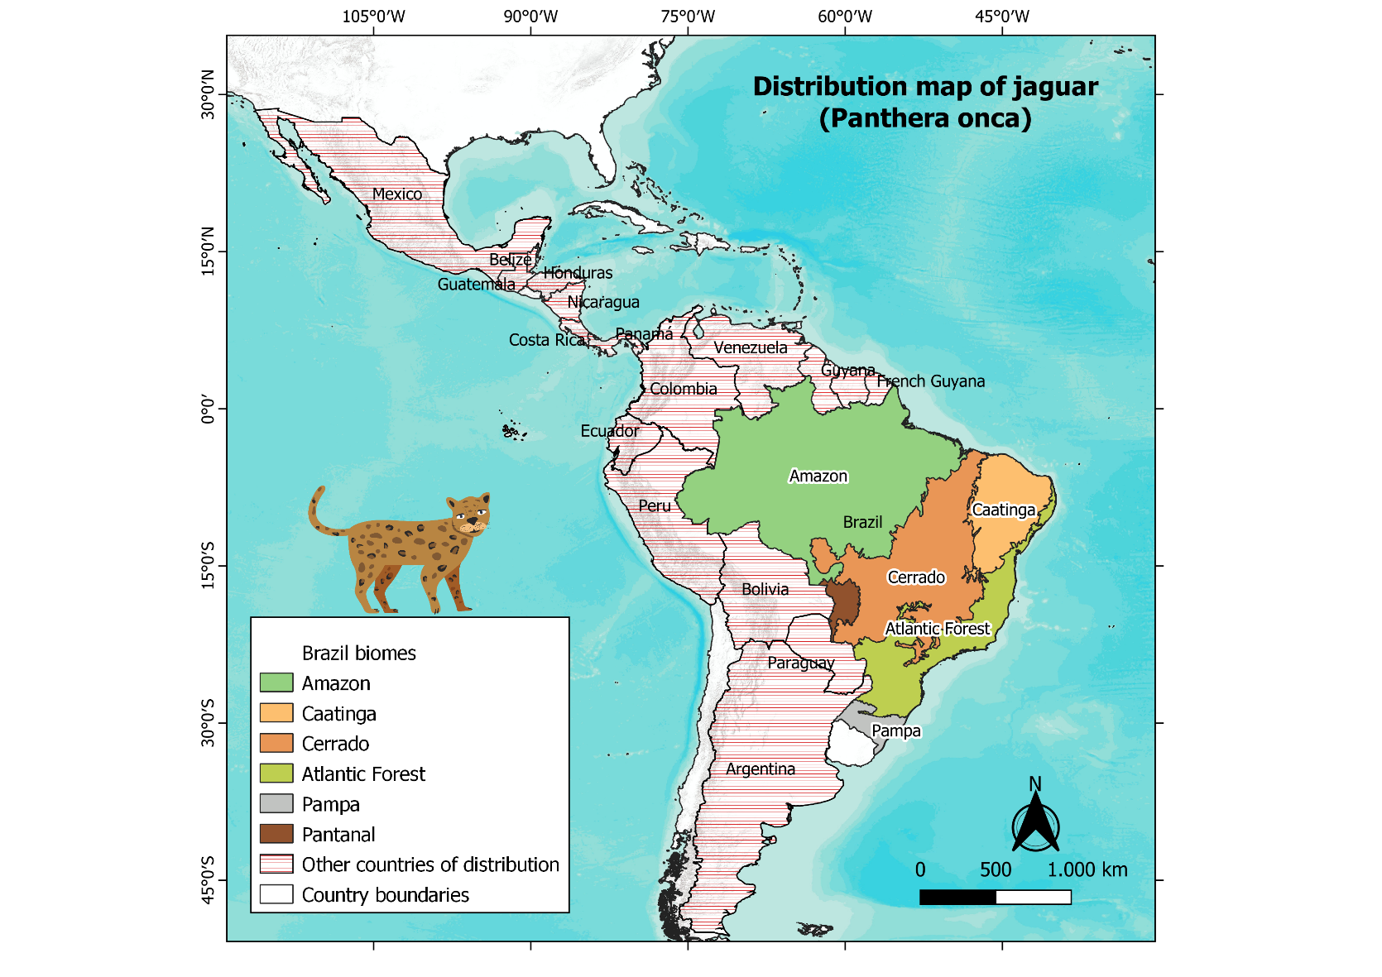

**Figure 1**: Distribution map of *Panthera onca.*

# Indicators and Goals

This section describes the goals of each Environmental Stewardship Indicator (ESI).

|  |  |
| --- | --- |
| **Indicator** | **Goal** |
| **Property Management** | Property management is an important factor that can contribute to a better ecological quality of a given habitat, reducing conflicts between humans activities and the jaguar conservation.  For example, deforestation is one of the main causes that leads to biodiversity loss. When animal species that live in the forest or native vegetation no longer have their habitat, therefore not being able to relocate, feed, or procreate, they will be more vulnerable and more likely to go extinct.  Notwithstanding, another important driver of hunting and persecution of large cats is livestock depredation, resulting in economic losses to local ranchers and farmers, a conflict that generates retaliatory culls. Assessing the potential or realized costs and benefits involved in large carnivore conservation is an essential task to be integrated into land management.  Finally, conservation strategies must consider natural hazards. For example, many actions can be implemented to prevent forest fires, such as controlled burning, opening permanent access to water sources and firebreaks. It is important that the management of fire at the project area is done in accordance with the design of integrated fire management plans, developed by the state agencies as a regional strategy. For any controlled burning action in a rural property, it is necessary to obtain prior environmental authorization, with a responsible technical professional, from the state environmental agencies. |
| **Social Engagement** | One of the main goals of jaguar conservation projects must be to influence development/infrastructure projects (mining, agroindustry, cattle ranching, logging) and their financiers to adopt social and environmental safeguards that include jaguar conservation requirements.  Therefore, developing social engagement activities is essential to raise awareness amongst diverse audiences and ensure the conservation of the species. For example, implementing awareness campaigns for drivers who travel in the surroundings of the project area can reduce the loss of biodiversity and the negative impact on wild animal populations, caused by road kills on the highways of the country. |
| **Financial Strategy** | A successful conservation project needs to focus on the adequate management of an area, based on practices that guarantee the occurrence of key species. It must also focus on promoting sustainable economic development and reducing conflicts and overlaps of land tenure rights or ownership. Wildlife tourism is a valid tool for species conservation. Big cats represent some of the most charismatic species appealing to a wide audience and are therefore of great value to wildlife tourism activities. Consequently, traditional communities involved with ecotourism are typically more tolerant of large cats and develop a healthy relationship that allows coexistence.  Conservation outcomes effectively depend on several factors, including local community participation and appropriate local financial trickle-down. Financial and political barriers must be reduced with the implementation of the project and with the inclusion of the community, generating jobs and economic alternatives to improve the quality of life in the area. |

# USp Strategies Guideline

The three indicators presented above are described in the table below, which contains the criteria and metrics for each indicator, the activities to achieve the expected status, and the documents/materials that provide evidence of the activities and support decisions for scoring. The table below also shows the impact assessment using the cost, difficulty to implement the strategy and the result as parameters that are calculated as an average. With the average calculate for each activity, the final score is estimated.

At the first monitoring report, project developers should score at minimum 20 (twenty) percent of the activities below, where three of these activities are mandatory: (2.1.a) Make firebreaks across the boundary of the property; (3.1.a) Security patrols and surveillance inside the Project Area; and (3.1.b) Use of remote sensing tools to identify deforestation and forest degradation.

It is expected forthe project to have procedures to establish continued improvement strategies, therefore it is mandatory that the final score in subsequent monitoring periods be **10% higher** than the period before.

If any of the strategies is not applicable for a specific project, the project proponent can exclude the score of the strategy from the total points of the specie guideline. The project proponent must use evidence to prove that strategy is not applicable. For example if firebreaks are not applicable to a specific project because the region is not prone to fires (trough satellite images or other evidence), this guideline should have a maximum total point of (58-5) 53 points.

|  |  |  |  |  |  |  |  |  |  |
| --- | --- | --- | --- | --- | --- | --- | --- | --- | --- |
| **Indicator** | **Criteria** | **Project Activity (Outcome)** | **Accepted Evidence** | **Cost** | **Diffic.** | **Resul.** |  | **Aver.** | **Score** |
| **Property Management Indicator** | 1.1 Improve property management techniques to reduce conflict. | 1.1.a Implement herd management (evaluation of areas susceptible to depredation and relocation of herds to other areas). | Present plan with the proposal for herd management. | 2 | 1 | 2 |  | 2 | 2 |
| 1.1.b   Implement anti-predation strategies associated with physical barriers, such as electric fences, fixed or movable, around the maternity houses and retreats where the herd is more predisposed to being depredated. | Photographic evidence or contract with the specialized contracted team. | 2 | 1 | 2 |  | 2 | 2 |
| 1.1.c. Implement anti-depredation strategies associated with light or sound effects, such as placing bells in the herd and the use of light repellents at strategic points to reduce animal traffic around retreats where the herd is more predisposed to being depredated. | Photographic evidence. | 1 | 1 | 2 |  | 1 | 1 |
| 1.1.d. Carry out lectures on environmental education for the property's employees. | Attendance lists and photographic evidence. | 1 | 2 | 1 |  | 1 | 1 |
| 2.1 Fire management: prevention and combat | 2.1.a Make firebreaks across the boundary of the property | Photographic report. | 3 | 3 | 3 |  | 3 | 5 |
| 2.1.b The project area has an Operational Plan for Integrated Fire Management, developed using the model provided by the responsible environmental agency. The plan has includes water truck availability, creation of fire breaks and constant maintenance, trained local fire brigade with equipment available for use, observation towers to detect fire outbreaks, sensors with alerts to detect fire prone conditions, and use of technologies such as drones for fire detection. | Present integrated operational plan of fire management and photographic evidence of attendance. | 3 | 2 | 3 |  | 3 | 3 |
| 3.1 Deforestation, Poaching and Forest Degradation | 3.1.a Security patrols and surveillance inside the Project Area. | Map with proposed rounds and surveillance and evidence of actions. | 2 | 1 | 3 |  | 2 | 2 |
| 3.1.b Use of remote sensing tools to identify deforestation and forest degradation. | Report using shapefiles. | 2 | 2 | 3 |  | 2 | 2 |
| 3.1.c Use deforestation detection technologies such as bioacoustics to identify agents, including machinery sounds, such as tractors or chainsaws, gunshots and other associated sounds. | Contracted expert advisory report or equipment report used. | 3 | 3 | 3 |  | 3 | 5 |
| **Social Engagement Indicator** | 4.1 Develop and implement an education and communication program | 4.1.a Implement a campaign to raise awareness of good practices for drivers in the project's surrounding area, especially for big cats, contributing to the reduction of roadkill rates of big cats. | Attendance list and photographic evidence. | 2 | 2 | 2 |  | 2 | 2 |
| 4.1.b Implement signs indicating protected areas, ban on hunting, burning, deforestation and with good driving practices on roads and highways in the project area and its surroundings. | Photographic evidence. | 2 | 1 | 2 |  | 2 | 2 |
| 4.1.c Report any road kills that occur in the project area and its surroundings, in order to provide statistics for research projects and/or surveys of roadkill animals. | Report including numbers of road kills and statistics. | 1 | 2 | 1 |  | 1 | 1 |
| 4.2 Implement a stakeholder relations program with rural assistance and extension agencies | 4.2.a Elaborate a communication plan for a stakeholder relations program. | Communication plan. | 1 | 2 | 2 |  | 2 | 2 |
| 4.2.b Develop a discussion workshop on land use, initiate a dialogue on more sustainable land uses, such as agroforestry systems, and encourage the implementation of these uses in priority areas, such as biodiversity corridors. | Photographic evidence of the workshop and attendance list. | 1 | 2 | 2 |  | 2 | 2 |
| 4.3 Establish a partnership with inspection agencies | 4.3.a Implement an institutional protocol for communicating events and environmental communication such as the recognition of potentially harmful activities, like hunting reports, improper use of pesticides and chemical products, etc. | Protocol and deployment report. | 1 | 2 | 2 |  | 2 | 2 |
| 4.3.b Establish joint actions with inspection and enforcement agencies, to make society aware of the hunting problem and aimed at preventing hunting (sport, amateur, commercial, and retaliation) and increasing the number of civilian complaints. | Reports of the joint actions. | 1 | 2 | 2 |  | 2 | 2 |
| 4.4Establish partnerships with the scientific community | 4.4.a Establish partnerships with the scientific community to implement a project to monitor big cats in the project area. | Contract or document for formalizing the partnership for monitoring and studies of large cats | 1 | 2 | 3 |  | 2 | 2 |
| 4.4.b Establish partnerships with the scientific community to develop studies based on samples of biological material from the capture effort. | Contract or document for formalizing the partnership for studies of large cats | 1 | 2 | 3 |  | 2 | 2 |
| **Financial Strategy Indicator** | 5.1Demonstrate funding for the project budget | 5.1.a Project has secured less than 15% of funding needed to cover the total cash out for the Project Timeframe | Spreadsheet with forecast and financial control. | 1 | 1 | 1 |  | 1 | 1 |
| 5.1.b Project has secured 15% to less than 40% of funding needed to cover the total cash out required to secure project activities for for the Project Timeframe. | 2 | 1 | 2 |  | 2 | 2 |
| 5.1.c Project has secured over than 40% of funding needed to cover the total cash out required to secure project activities for for the Project Timeframe. | 3 | 2 | 3 |  | 3 | 3 |
| 5.2. Implement a communication program to mobilize and increase financial resources | 5.2.a Implement a communication program to mobilize and increase financial resources from all sources to conserve and sustainably use biodiversity and ecosystems. | Communication program and photographic evidence. | 2 | 3 | 3 |  | 3 | 3 |
| 5.3 Implement an Ecotourism Program at the project area | 5.3.a Develop and implement a business plan for the implementation of an ecotourism product related to the conservation of the project area, focusing on the sighting of big wild cats. | Business plan for ecotourism and report of implemented actions. Partnership contracts with ecotourism companies. | 3 | 3 | 3 |  | 3 | 5 |
| 5.3.b Elaborate a communication plan for a stakeholder to promote the project area as an ecotourism destination. When possible, involve research centers and small businesses in building multisectoral and multistakeholder solutions, creating local employment through the implementation of project activities. | Communication plan focused on ecotourism and report of actions performed. | 3 | 2 | 2 |  | 2 | 2 |
| 5.3 c Establish commitment terms with observatories, associations, and secretariats related to public policies for the promotion of sustainable tourism. | Term of commitment. | 1 | 2 | 3 |  | 2 | 2 |
|  |  |  |  |  |  |  |  | Total | 58 |

1. Eriksson, C. E., Kantek, D. L., Miyazaki, S. S., Morato, R. G., dos Santos‐Filho, M., Ruprecht, J. S., ... & Levi, T. (2022). Extensive aquatic subsidies lead to territorial breakdown and high density of an apex predator.
2. WWF. (2020). WWF Jaguar Strategy 2020-2030. Available at: https://wwflac.awsassets.panda.org/downloads/estrategia_jaguar_2020_2030_wwf.pdf